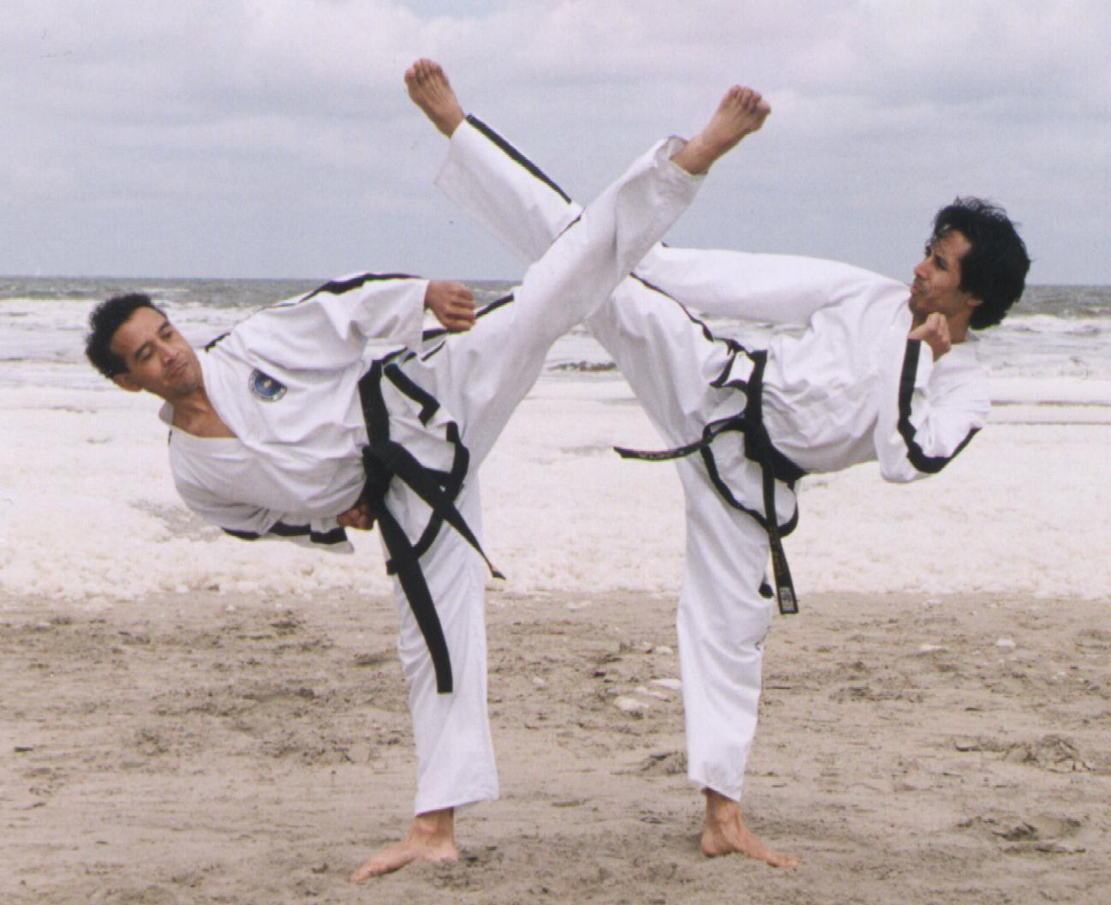
Master Wijnand Tapilatu VII Dan ITF
Hoendiep 203 – Hoogkerk – 0031 50 556 7298  www.tapilatu-sportcenter.nl



With support from Pro Martial Arts Tour
www.promatour.nl and http://promatour.hyves.nl/

Date:
Sunday May 10th 2009

Place:
Sports hall Hoogkerk, Zuiderweg 70-1, Hoogkerk, the Netherlands

Time table:
Sporthall open: 08.00 hour
Measuring / Weigth in 08.30-09.15 hour
Coach/Umpire meeting: 09.30 hour
Opening: 10.00 hour
Start Tuls 10.15 hour
Start Sparring around 12.00 hour
Pauze: 13.30 hour

Events and categories::
- Semi-contact individual sparring (I.T.F-Taekwon-Do rules);
Sparring Individueel: A / B klasse (kids/junior/senior)
B. Pool system sparring for junior/senior A classes with 10 competitors or less.
C. Tuls. (Individual with traditional pyramid system)

Sparring Time:
Kids: 1 x 1,5 minutes
Junior/Senior B classes: 1 x 2 minutes
Junior/Senior A classes: 1 x 2 minutes
Junior/Senior A classes 1 x 2 minutes (pool system)(The organizer has the right to change the time)

Divisions and classes:
- There are divisions and classes for kids, juniors and seniors
- They are divided in grading, length and weights;
- There will be a maximum of 250 competitors allowed!!
- Every event we use the knock-out system (1x 3e place.)
- Male/Female Kids/Juniors/Seniors are divided in separate classes.

Ages:
Kids Female: -14 year.
Kids Male: -14 year.
Junioren Female: 15 - 17 year.
Junioren Male: 15 - 17 year.
Senioren Female: 18 +
Senioren Male: 18 +

Classes Sparring:
A division: blue belt and higher (continue system)
B klasse: white up to green/blue belt (pointsysteem)

1. All competitors must have full insurance cover.
2. No boxing or open gloves allowed, shoft shin protectors are allowed, kids must wear headquard during sparring!!.

Length Sparring:
Kids Female: -130, -140, -150, -160, -170, +170 cm.
Kids Male: -130, -140, -150, -160, -170, +170 cm.

Weight categorie Sparring:
Junior Female: -45, -50, -55, -60, +60kg
Junior Male: -52, -58, -63, -70, +70 kg
Senior Female: -52, -58, -63, -70, +70 kg
Senior Male: -54, -63, -71, -80, +80 kg

Changes to the categories can be made but will cost €10,- per change.
The organization reserves the right to put divisions together.

Tuls: 2 competitors against each other. Competitors perform 1 optional Tul.

1. White/White Yellow Belt: up to Dan-Gun
2. Yellow/Green/Green-Blue Belt up to Yul Gok
3. Blue/Red/Red-Black Belt: up to Choong-Moo
4. Black Belt I-degree up to Ge-Baek
5. Black Belt II-degree up to Juche
6. Black Belt III-degree up to Choi-Yong
7. Black belt IV-degree and up up to Moon-Moo

Divisions will be amalagated if there not enough competitors in a division.

Umpires:
Must wear, blue/black trousers, white shirt long sleeves, blue/black tie.
Every club/team must bring umpires. If no umpire is submitted there will be a fine of €.75,- for every missing umpire.
Up to 9 competitors 1 Umpire
10 till 14 Competitors 2 Umpires
15 competitors ore more 3 Umpires

Coaches:
2 coach 1 up to 7 competitors
3 coaches 8 up to 14 competitors
4 coaches 15 up to 20 competitors
5 coaches 21 competitors or more

Rules:
Semi-contact individual points:
- 1 point for all hand techniques head/chest;
- 2 points for all kicks at the chest;
- 3 points for all kicks to the head.

Points, warnings, minus points and disqualification are recording
I.T.F.- AETF Taekwon-Do rules,
http://www.tkd-itf.home.pl/pub/ver_eng/comp_rules.html or
http://www.itfeurope.org/competition_rules.html
In case of a dispute the Head referee have the final decision.

Press:
No press allowed, pictures can be taken of the tribune that is very close to the arena’s.

Fees competition:
Sparring or Tul 20.00 Euro
Sparring and Tul 25.00 Euro

Entry forms send to:

Henny van Zon
Dommelseweg 87A
5554 NM Valkenswaard
Netherlands
To info@sportprijzenvalkenswaard.nl
And:
Master Wijnand Tapilatu
Hoendiep 201
9745 ED Hoogkerk
Netherlands
w_tapilatu@hotmail.com

The deadline for the entry form is Monday April 27th 2009!!

Hotel accommodation: For help, send Master Tapilatu email.
*There will be no transportation to the hotels or to the sport hall!!

Tournament Directors:
Master Wijnand Tapilatu
Henny van Zon

Contact International:
Master Wijnand Tapilatu
Tel: +31-(0)50 5567298
Mobile: +31-(0)6-22807906
E-mail: w_tapilatu@hotmail.com

Contact National
Henny van Zon
Tel: 0031 40 2070920
Fax: 0031 40 20 709 30
Mobile: 0031 6 53 93 25 79
E-mail: info@sportprijzenvalkenswaard.nl

The Open Tailatu’s Taekwon-Do is a Pro Leaque tournament, www.promatour.com

